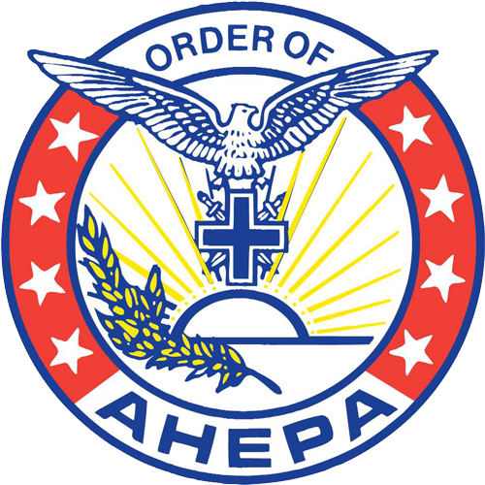

Technology Tool Kit for CHAPTERS:

AHEPA District Web Sites and Public Relations in a Digital Age

Tools for Better Communication

Social Media
Social media is a useful tool to grow and spread the word on your chapter. There are many platforms out there now and each has its own style.
Facebook: The king of the social media platforms. It is the most flexible and allows users to interact with each other and create groups or events.
Instagram: Essentially Facebook’s little brother. It is a picture sharing platform.
Twitter: A way to send out messages and news in brief statements.

Facebook is by far the biggest and probably the most important to our organization. I would recommend that each chapter have its own Facebook group. Facebook is great because it is free and easy to set up. There are many tools that are useful that are already built into the platform such as: messaging, groups, photo sharing, and event creation.

Social Media Tools: There are many tools online, here are a few to help you out.
LATER.COM – Later allows you to schedule social media posts. This is useful so that you can plan when you post for meeting and events, so they get good coverage and enhance participation. It’s also free up to 30 post a month and easy to set up.
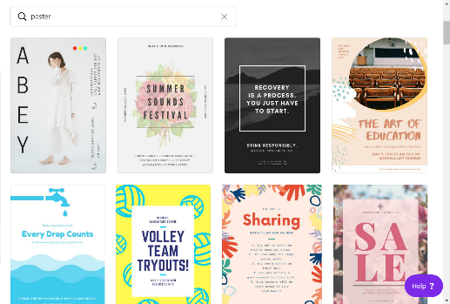
CANVA.COM – An online graphics tool. It has a lot of templates and styles premade and will help you create sexy posts for your events. It can also make flyers and presentations as well. It’s basic functions are free.

EMAIL Management
Your chapter should be maintaining an email list for its members. Email lists are a free and easy way to send your members newsletters and information about upcoming events and meetings.
*A suggestion would be to create a separate email list for potential members. These emails can be gathered from events and your website. These potential members can be informed of what AHEPA is doing in the community and of any events on the horizon.

Tools for email management:
GMAIL.COM – Google provides email services. They are free secure and include tools like GSuite (Drive, Docs, Calendar)
MAILCHIMP.COM – An online tool to manages contacts and schedule emails. It is free for the first couple thousands of members on your list.

Your Website
Website are another important tool for organizations. Having your own website allows you to have further control over your content as well as integrate other features that would help with communication.
The basics for a site should include your name, contact info, an announcement of the next meeting and events, a way to gather potential member emails. Other information that could be included on the site is a history of your chapter and officer bios.
The website can also be used to gather member dues and online donations. It streamlines the process and makes it easier for people to give to the chapter.
You can build your own website with any of the tools available online today. Squarespace or WIX These aren’t free they range from $15+ a month and some features are usually extra.
A web designer can build your site, it’ll look professional and they should be able to integrate many features like online donations. Their prices vary.

Online Forum
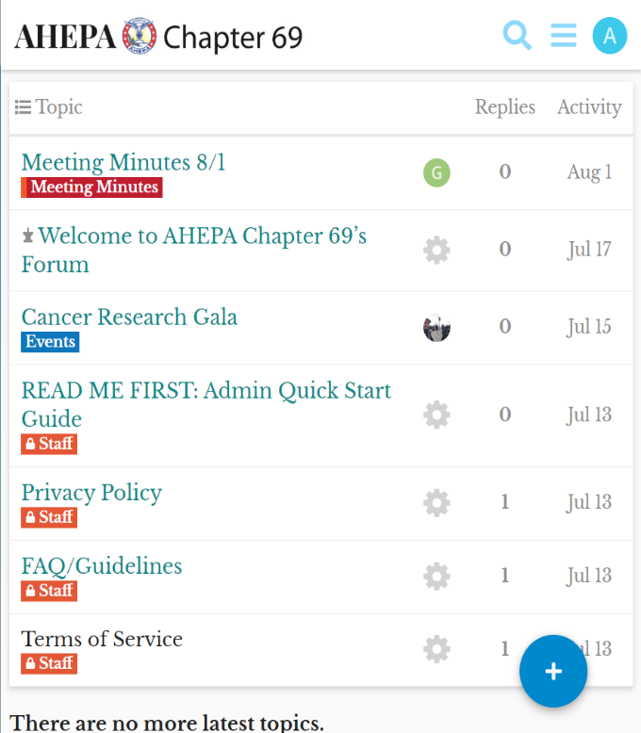
An online forum is great tool to have. It becomes a space where conversation from meetings are extended to and ideas can be brought up for discussion. The forum can be set up to be for members only and brothers are invited to join. It works to keep members better informed and thus makes meetings more productive.
Forums are great because it becomes, they group conversations together, so the topic remains a cohesive thread. It works as an online source where members who could not attend the meeting can check out minutes and ask and respond to questions and issues.
Some forum solutions: These are a little more technical to set up, so someone a little more tech savvy would be helpful.
DISCOURSE – It is one of the best forum software out today.
Other forum software = FORUMBEE – VANILLA FORUMS - BBForums

Tools for Organizational Management

Online Banking
In the year 2019 every bank offers free online banking, if they don’t, get out. Online banking is great as it adds a layer of transparency within the organization as well as helps the treasurer keep track of funds and where they go.
Tip: Many banks allow you to have multiple accounts for an organization; A good idea would be to have one where dues online and in person can go, one general bank account and a petty cash account with a debit card for various expenses. With online banking it’s easy to transfer funds within these linked accounts and everything can be tracked.
Online financial tools:
QuickBooks is the most famous financial software. It is great but it isn’t free.
Wave App is a free alternative to QUICKBOOKS. It can link to your bank account and gives your real time reports and spending analysis. A perk of this is you can create invoices that can be paid online, this is a useful way to have your members pay their dues.
PAYPAL – One of the largest online payment platforms. Having a PayPal for your chapter is a great way to be flexible with receiving payments.
- Please note that receiving payments online is not free! Payment processors always take a cut so please be diligent and try to get the lowest possible percentage. WaveApp for example is 2.9% + $0.30 for transactions

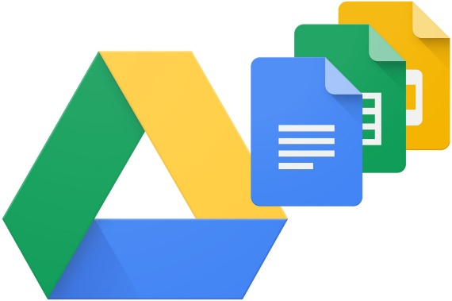
Google APPS
Setting up a Gmail for the chapter is a great way to have a secure email address that also has the perks of a google drive (an online storage system) which can be used to store online forms, documents, and photos.
The benefits of having a Google drive is it can become an easy folder to share and update documents.

Event Promo
Greeks like to party! As an organization we throw many different types of events. Here are some tips to better promote your next event.
FACEBOOK – Facebook is a super useful tool when it comes to event promotion. Creating an event is simple and all the information is easily formatted so guests can see the details easily. You can promote it out to as many people as you’d like, and guest can even spread the word for you. Guest can show their interest and who is coming so planning accordingly becomes easier.
Sometimes events require ticket sales and to help manage that there are platforms like EVENTBRITE. With Eventbrite you can make events and sell tickets online. It’s great for dances or concerts. These ticket sales platforms can be easily integrated into your website or Facebook page.
CANVA was mentioned earlier ill mention it again because it is a great tool to make printable flyers as well as good looking social media posts.

FURTHER RESOURCES:
I plan on posting more tips and tools online at www.AHEPA69.org/TOOLS

