ATHENS 2021
PREPARE FOR A CONVENTION TO REMEMBER
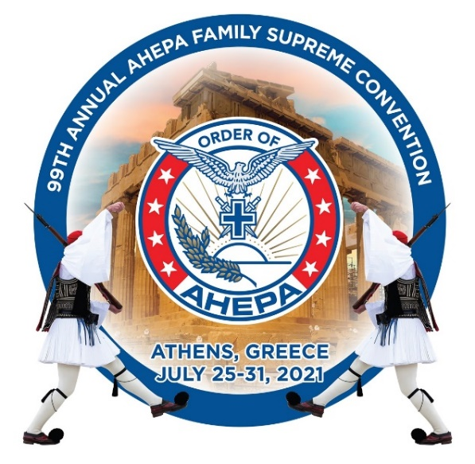
AHEPA Global Headquarters is pleased to announce the 2021 AHEPA Supreme Convention in Athens Greece. AHEPA has been working with all the ministries in Greece preparing for events and programs. This will be once in a lifetime convention!
As all of you know Greece will be celebrating their Bicentennial. AHEPA is going to be part of the events and we want all of you to attend. Currently our tentative schedule looks something like this:
AHEPA Supreme Convention – Athens 2021
Sunday, July 25 Supreme Lodge Meeting, Board Meetings,
Opening Ceremonies Honoring Mayor of Athens
Monday, July 26 Registration Begins, General Session
99th Supreme Convention Anniversary Event ZAPPIEON Honoring members of the Government of the Hellenic Republic
Tuesday, July 27 General Session, Golf Tournament Glyfada Golf Course, District to Host an event. AHEPA Family Awards Luncheon Honoring members of the Greek government
Wednesday, July 28 Sessions, AHEPA Athletic Luncheon,
Greek Night Acropolis Museum Hosted Event,
Thursday, July 29 Meetings Continue, Symposiums, Governors Meeting
Special Awards Ceremony Reception 5:30PM.
Presidential Palace Event Honoring President of Greece.
Friday, July 30 General Sessions, Elections,
Grand Banquet & Ball (Hilton Hotel) Honoring Prime Minister Kyriakos Mitsotakis
Saturday, July 31 AM Instillations/Meetings. Check out/Departure,

MAKE SURE TO MAKE RESERVATION TODAY AS ROOMS ARE LIMITED!

Visit this link to make reservations today: https://bit.ly/31MFUzj
- All events in Bold are included in the Delegate/Alternates/Guest package
All Meetings will be held at our headquarters hotel: The GRANDE BRETAGNE Hotel.
AHEPA has made special arrangements for our stay. The Special AHEPA rates can ONLY be reserved by contacting AHEPA through the AHEPA portal at AHEPA.ORG.

Rates:
Classic Rooms: 280 Euro* per room for single/290 Euro* for a double room (2 people)
Rooms can have one King bed, or two twin beds, your choice

Deluxe Rooms: 320 Euro* per room for single/330Euro* for double room (2 people)

All guests get complimentary full breakfast daily.

All delegates and guests MUST send in $260 NON-Refundable Deposit to secure their room. We have limited rooms, so act quickly. AHEPA will send $100 per deposit per room which will be deducted from your total bill you will pay upon check out. You must be a member of AHEPA to receive this reduced rate.
*Exclusive of all taxes

VISIT the AHEPA web site for details on our planned events and to secure hotels, and cruise info.

AHEPA Convention Page: https://ahepa.org/supreme-convention/

AHEPA Hotel Reservations page: https://bit.ly/31MFUzj

Convention Itinerary: https://ahepa.org/wp-content/uploads/2020/09/2021-Convention-Info-Package-Sm-2.pdf

Individual Sponsorship form (Tier 1): https://ahepa.org/wp-content/uploads/2020/09/2021-Convention-Sponsorship-2-Fillable.pdf

Corporate Sponsorship form (Tier 2): https://ahepa.org/wp-content/uploads/2020/09/2021-Convention-Sponsorship-1-Fillable1Sm.pdf

AHEPA will be making arrangements with flights and advising of special pricing in the months ahead.

Post AHEPA Convention Events. The AHEPA will be working with local chapters throughout Greece and District 25 to offer special tours and trips which will show different places of Greece. Currently we are discussion visits to:

Rhodes, Crete, Mykonos, Thessaloniki, and Cyprus

Want a cruise, join other members on the Celestyal Cruise July 31-August 7 email: cruising@celestyal.com or Call for the AHEPA Discounted rate with promo code “AHEPA” or call 877-337-4665/ reservations@celestyal.com

